HOW TO Activate a New Outlet for Budgeting

Description
This procedure outlines the steps to activate or enable budgeting for an outlet that has not been used before at a hotel.

Step 1 – Turn on Accounts in Buddy
Go to the Utilities menu in Buddy and choose the item “Select Additional Accounts to Use”. Check all the applicable accounts and click OK. Be sure to check accounts for Covers, Meal Period Revenues and Beverage.
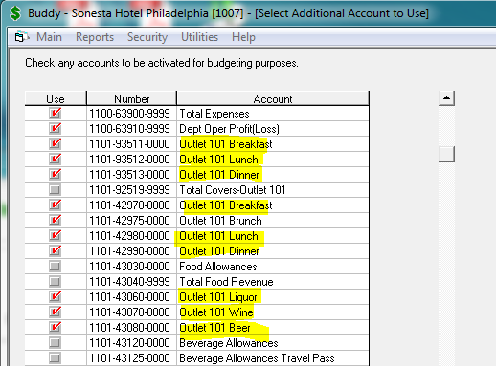
Click OK and then confirm that you are activating these accounts by clicking Yes on this screen:
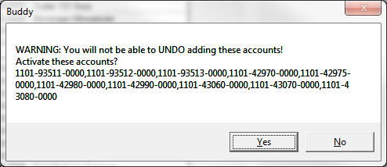
Exit Buddy.

Step 2 – Make Sure that User has Rights to the Department
In many cases, each outlet is a separate department in Buddy. In this case, select “User Security” on the main menu, select a user and then select “Buddy”. Make sure the department is checked.
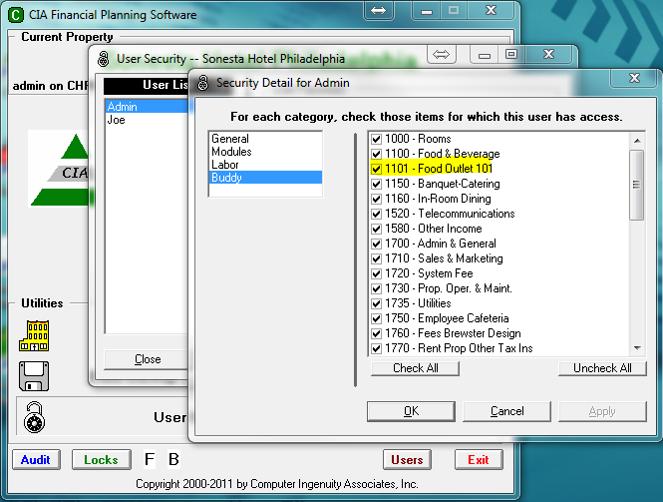

Step 3 – Export Forecast & Budget to DSTAT
The export to DSTAT makes sure that all applicable meal periods are activated for forecasting. Go to the Administrative Options menu and select “Export Forecast & Budget for DSTAT”. Then, click Yes to the question shown below:
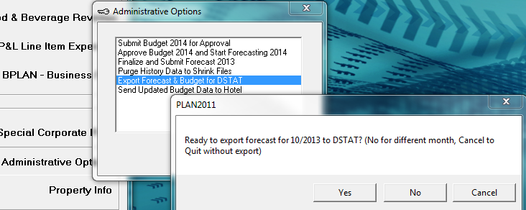
This process may take up to several minutes depending on the speed of your network. When it is completed, you are ready to activate the outlet in FBREV.

Step 4 – Turn the Outlet “on” in FBREV
Go to the Utilities menu in FBREV and select the “Setup Outlets” item.
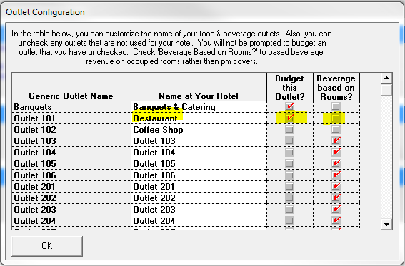
- Type the Name of the outlet.
- Check the box in the “Budget this Outlet?” column. This enables it for budgeting.
- Check the box in the “Beverage based on Rooms?” column only if the outlet beverage revenue is driven more by occupancy (e.g. lounge), rather than by food covers (e.g. restaurant).
Click OK.

From Buddy click on the Utilities Menu Option and select “Load Data from DREV/FBREV”
Then from the Utilities menu option select the “Auto Create Report Sub Totals”

The outlet is ready for use in FBREV.

