Enter Meeting Room Rental at Sonesta ES Hotels
Room Rental Revenue is posted to the Banquets Dept (1151) and is forecasted in the FBREV module of CIA. To enter the forecasted Room Rental for the first time, follow these steps:
1. Log into CIA, and click on 'FBREV - Food & Beverage Revenue'
2. Go to the Utilities menu and select 'Setup Outlets'. On the line labeled "Corporate (Group)".
a. Under Name type "Banquets"
b. Check the box for 'Budget this Outlet'
c. Click the OK button
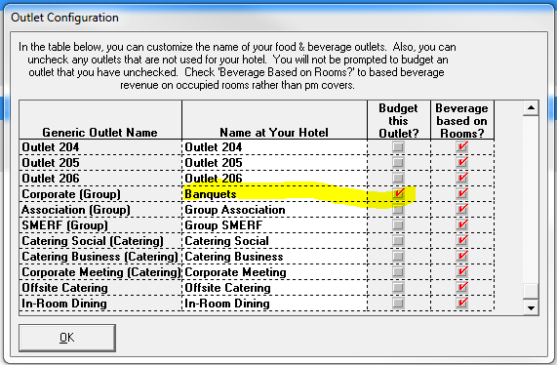
The above steps must be done only time. You will not have to do this each month.

3. From the main FBREV screen, click the button labeled "Change 2013 Forecast"
4. On the next screen, set the Outlet to Banquets, set the Revenue to Other and click the link for "Change Forecast"
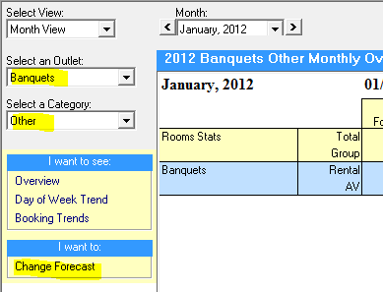
5. On the next screen, enter the monthly forecasted room rental. Make sure to select the correct month at the top of the screen.
When all future months are entered, close FBREV and save data. When you enter the Buddy program, these revenues will automatically import to the forecasted P&L.
