Procedure for Setting Up PDF Printer for Use in CIA and DSTAT

Description
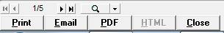
CIA Financial Planning and DSTAT can print any report to PDF format from the report preview screen by clicking the PDF button (or Email button). To perform this function, the software must setup a temporary printer named ‘CIA PDF Printer’ and output the report to that printer. The user must have local administrator rights to create the printer. Note that this procedure has changed for 2013.

For most users, the CIA PDF Printer is created as needed when PDF output is requested. However, some users do not have rights to create a printer on their local computer. In this case, an alternative method of creating the CIA PDF Printer before launching CIA Financial Planning is needed. Whether the user has rights to create a printer or not, creating the PDF printer up front will make PDF generation faster.

Downloading the Setup
The setup program for creating the CIA PDF Printer is now included as part of the “BudClient” (and DstatClient for cases where CIA Financial Planning is not installed). You must use a BudClient dated after June, 2013. It can be downloaded using the URL:
http://www.ciasoft.com/BudClient.EXE

Save this file to the CIA\Budget folder on the hotel’s server. This will make it accessible to all users of CIA Financial Planning.

Running the Setup
Using an account that has administrative rights, or using “Runas Administrator”, double-click BudClient.EXE to run it. This will setup CIA Financial Planning to run on the local computer. It will also create the folder CIA\Budget\PDF and copy PDF printer driver files to it.

Setting Up the Printer (Optional)
If the user does not have right to create printers, it will be necessary to create the printer prior to running CIA Financial Planning. Do this by opening the CIA\Budget\PDF folder, find the file named InstallCIAPrinter.bat and double-click to run it. If successful, you should see a window like this:
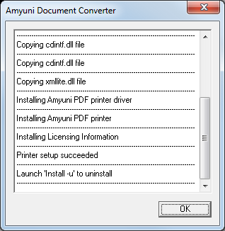
(Note: you must have local administrator rights to run this setup)

Click the OK button in this window.

Verifying the Printer Setup
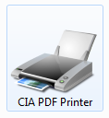
To verify that the PDF printer is created and ready to use, click the Start button and then click ‘Devices and Printers’. If the previous steps were successful, you will see a device icon labeled ‘CIA PDF Printer’. At this point, the local computer will have a “permanent” printer that CIA Financial Planning and DSTAT can use to create PDF output.

Troubleshooting
Follow these steps if clicking the PDF button produces an error:
- Open “Devices and Printers” (under Control Panel). If there is an existing printer named “CIA PDF Printer”, remove it by right clicking and selecting “Remove Device”.
- Open the PDF folder located under the Budget folder. All the DLLs should be dated 2/13/2013 or later. If they are earlier, download the latest BudClient.exe from the CIA website and run it on the workstation.
- Find the file named “InstallCIAPrinter.bat” and run it. That should create the “CIA PDF Printer”.
- If the error persists, right click on “CIA PDF Printer” and select “Printer Properties”. Then, click on the Ports tab. Create a port named “nul:” and assign it to the CIA PDF Printer.
