Procedure for Setting Up PDF Printer for Use in CIA and DSTAT
NOTE: This procedure is to be used for CIA Financial Planning version prior to February, 2013. For newer versions, please see updated instructions.

Description
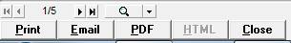
CIA Financial Planning and DSTAT can print any report to PDF format from the report preview screen by clicking the PDF button (or Email button). To perform this function, the software must setup a temporary printer named ‘CIA PDF Printer’ and output the report to that printer. The user must have local administrator rights to create the printer. Further on 64bit platforms (e.g. Windows 7-64), the printer port must be changed from the default of LPT1:.

A new method of creating this temporary printer has been implemented in which the CIA PDF Printer is installed once (by an administrator) and then not removed when printing is complete. This is useful when users do not have rights to create printers. It also solves issues printing on 64 bit systems.

Downloading the PDF Setup
The setup program for creating the CIA PDF Printer can be downloaded using the URL:
http://www.ciasoft.com/PDFSetup.EXE

Save this file to the CIA\Budget folder on the hotel’s server. This will make it accessible to all users of CIA Financial Planning.

Setting Up the Printer (All Systems)
Go to the CIA\Budget folder and run PDFSetup.EXE (double click the file to run).

The PDFSetup program will create a folder CIA\Budget\PDF and copy files to it. Then, a Windows Explorer window will open showing the files. Find the file named InstallCIAPrinter.bat run it (double click). If successful, you should see a windows like this:
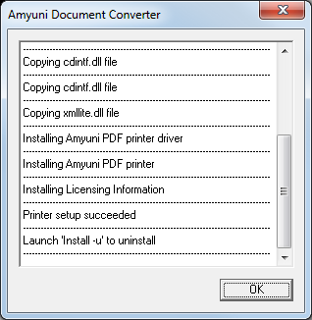
(Note: you must have local administrator rights to run this setup)

Click the OK button in this window. Then, click the button to close the setup program.

Changing the Printer Port (Windows 64 bit Systems Only)
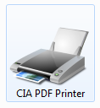
Click the Start button and then click ‘Devices and Printers’. If the previous steps were successful, you will see a device icon labeled ‘CIA PDF Printer’.

- Right click this icon and select ‘Printer Properties’.
- Click the Ports tab.
- Click the Add Port… button
- Select ‘Local Port’ and then click the New Port… button
- For the port name, enter CIAPDF and then click the OK button
- Close the Printer Ports window
- Click the Close button on the CIA PDF Printer Properties window

At this point, the local computer will have a “permanent” printer that CIA Financial Planning and DSTAT can use to create PDF output.

Troubleshooting
If you click on the PDF button to output a report in PDF format and get an error, follow these steps prior to contacting Technical Support. Exit CIA Financial Planning before following these steps.
- Click the Start button and then click ‘Devices and Printers’. Do you see a printer named “CIA PDF Printer”? If so, right click on this icon and select “Remove Device” to remove the printer so it can be recreated in the following steps. If no CIA PDF Printer exists, go directly to #2 below.
- Using Windows Explorer, see if the folder CIA\Budget\PDF folder exists. If not, go back and follow the instructions in the above section titled “Downloading the PDF Setup” and then continue with the instructions under “Setting Up the Printer (All Systems)”. If the second to last message in the dialog box does not say “Printer setup succeeded”, then you likely do not have the administrative right to install the printer. In this case, you must contact your company’s Helpdesk for further assistance; and reference these instructions.

