Error 31104 - Tab control must have a tleast one visible Tab at 962 in Buddy frmBudgetInput:cboAccount_Click() at 1293

Summary
When using the Buddy program, the user may get the message:
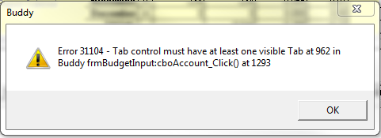

Cause
There is a known issue in Buddy when the user click on the button labeled: Turn Calcs OFF
The user may also be prompted about turning calculations OFF if calculations take a long time (i.e. more than a few seconds).
If Calcs are Turned OFF and then the user clicks to move to the next account, this error will be generated.

Solution
Until this bug is fixed, users are advise to not turn Calcs OFF.
